**Teacher feedback Form 2020-21**

Forms response chart. Question title: Curriculum and Syllabus are need based.
. Number of responses: 11 responses.

Forms response chart. Question title: The Programme Outcome and Course Outcomes are well defined.
. Number of responses: 11 responses.

Forms response chart. Question title: Sufficient number of relevant reading material / books /reference books and digital resources are available in Library.
. Number of responses: 11 responses.

Forms response chart. Question title: The course has good balance between theory and application.
. Number of responses: 11 responses.

Forms response chart. Question title: Syllabus of this course has increased my knowledge and perspective in subject.
. Number of responses: 11 responses.

Forms response chart. Question title: I have freedom to Propose, suggest and incorporate new topics in the syllabus through proper forum.
. Number of responses: 11 responses.

Forms response chart. Question title: I have freedom to adopt new techniques/ education tools/ strategies in teaching methodology.
. Number of responses: 11 responses.

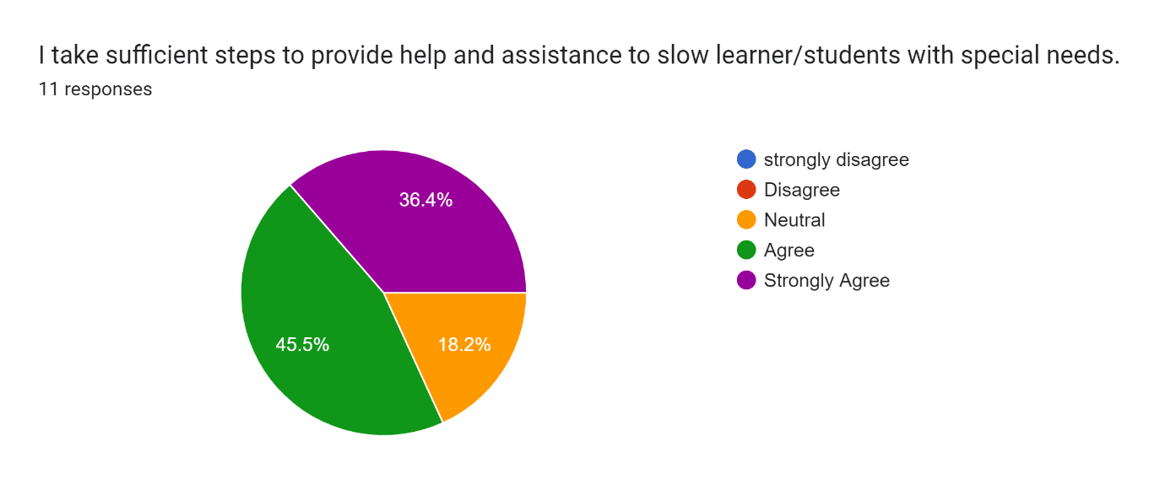

Forms response chart. Question title: I have contributed to the curriculum and/or syllabus development.
. Number of responses: 11 responses.

Forms response chart. Question title: I have freedom to take the students to field visit, experimental learning, etc.
. Number of responses: 11 responses.

Forms response chart. Question title: I use latest ICT tools like projectors,YouTube channels,PPT etc. or providing course material.
. Number of responses: 11 responses.

Forms response chart. Question title: I relate the course material to real world situations.
. Number of responses: 11 responses.